UDC 662.758.4:552.576.1:66.088
Electrohydraulic Percussion Unit for Coal-Water Fuel Production
A. Unitsky ^{1, 2}, Ph.D. in Information Technologies (Transport)
N. Pershay², Ph.D. in Engineering Sciences
S. Arnaut², Ph.D. in Engineering Sciences
I. Borisevich²
D. Konyok ²

¹ Astroengineering Technologies LLC, Minsk, Belarus
² Unitsky String Technologies Inc., Minsk, Belarus

The results of using UniThorr 2 electrohydraulic percussion unit, designed by Unitsky String Technologies Inc. (Minsk, Belarus), to produce coal-water fuel (CWF) are provided. The impact of various parameters (solids content, particle size distribution) on the rheological properties and sedimentation stability of coal-water slurries has been studied, which made it possible to select the formulation of CWF. The process flow of electrohydraulic percussion unit manufacture including its operating is proposed on the basis of experimental evidence; patterns between the process parameters of CWF are distilled; the optimal fuel composition is determined. It is demonstrated that by adjusting the particle size distribution of CWF it has been possible to reduce the dynamic viscosity of the samples by six times.
The developments in this area are an important component of the implementation of the EcoSpace program, in particular in the energy (heat and electricity) and biohumus production in the equatorial linear city for the needs of the General Planetary Vehicle and the industrial space necklace “Orbit”.
Keywords: brown coal, coal-water slurry (CWS), coal-water fuel (CWF), dynamic viscosity, dispersion, industrial space necklace ”Orbit” (ISN “Orbit”), sedimentation stability, electrohydraulic effect, electrohydraulic shock installation (EHSI) , UniThorr.

Электрогидроударная установка для получения водоугольного топлива

А.Э. Юницкий^{1, 2}, доктор философии транспорта
Н.С. Першай², кандидат технических наук
С.А. Арнаут², кандидат технических наук
И.О. Борисевич²
Д.А. Конёк²

¹ООО «Астроинженерные технологии», г. Минск, Беларусь
²ЗАО «Струнные технологии», г. Минск, Беларусь

Представлены результаты использования электрогидроударной установки UniThorr 2, сконструированной ЗАО «Струнные технологии» (г. Минск, Беларусь), для получения водоугольного топлива (ВУТ). Исследовано влияние различных параметров (содержание твёрдой фазы, гранулометрический состав) на реологические свойства и седиментационную устойчивость водоугольных суспензий, что позволило подобрать рецептуру ВУТ. На основании экспериментальных данных предложена технологическая схема его изготовления, включающая использование электрогидроударной установки; выявлены закономерности между технологическими параметрами ВУТ; определён оптимальный состав топлива. Показано, что путём корректировки гранулометрического состава ВУТ удалось уменьшить динамическую вязкость образцов в шесть раз.
Разработки в указанной области являются важной составляющей реализации программы «ЭкоМир», в частности в производстве энергии (тепловой и электрической) и биогумуса в экваториальном линейном городе для нужд общепланетарного транспортного средства и космического индустриального ожерелья «Орбита».
Ключевые слова: бурый уголь, водоугольная суспензия (ВУС), водоугольное топливо (ВУТ), динамическая вязкость, дисперсность, космическое индустриальное ожерелье «Орбита» (КИО «Орбита»), седиментационная устойчивость, электрогидравлический эффект, электрогидроударная установка (ЭГУ), UniThorr.

Introduction
The Industrial Space Necklace “Orbit” (ISN “Orbit”) is a multi-orbital industrial-residential complex with a developed transport infrastructure, built according to the model of an equatorial linear city and encircling the planet along the equatorial plane. It will supply the Earth’s population with space products, act as a buffer in the event of threats to the Earth’s civilization from space (including meteorites), and serve as a technological platform for deep space exploration [1–6].
The structure of ISN “Orbit” includes EcoCosmoHouse (ECH), which are orbital structures with habitable internal spaces protected from the harsh external conditions of space [3–4]. In such an environment, there is a pressing need to create closed biosphere-type ecosystems that provide a full cycle of self-sufficiency for people.
When developing these ecosystems, preference should be given to equipment and technologies that operate on electricity. This is due to the inexhaustible source of solar energy in space, which can be converted into electricity [4]. Accordingly, the use of an electrohydraulic shock installation (EHSI) in Earth orbit will be a good alternative to traditional methods used in various industrial technologies.
The principle of EHSI operation is based on the electrohydraulic effect: an electric discharge occurs within a volume of liquid, creating ultra-high impulse pressures around the discharge zone capable of performing mechanical work and accompanied by a complex of physical and chemical phenomena [7]. The main advantages of implementing electrohydraulic technology in space life are its environmental friendliness and safety.
The use of EHSI in industry is quite diverse. There are many directions for the use of electrohydraulic shock: in mechanical engineering, construction, mining, medicine, agriculture, energy, and more. Since one of the goals of building ISN “Orbit” is to transfer harmful industries from Earth to it, replacing traditional technologies with EHSI in the new environment will be a reasonable solution.
In the implementation of the EcoSpace program, particularly for the purpose of obtaining energy and biohumus in the equatorial linear city for the needs of ECH, the use of EHSI is proposed. The possibility of producing biohumus from crushed brown coal using such a unit is demonstrated in [8]. The electrohydraulic effect can also be used in fuel production technology (in this case, we are talking about coal-water fuel CWF) [9], as confirmed by experimental results presented in this study.

Prospects for Using Coal as Fuel
Electric and thermal energy are obtained by burning various types of fuel, such as wood, peat, coal, gas, oil, and others. The main fuel resources include oil, natural gas, and coal, which produce more than 80% of the energy generated on the planet [10].
Global geological fuel reserves are estimated at approximately 13 trillion tons, meaning that humanity’s supply of mineral fuel is about 1,000 years at the current level of consumption. Of these reserves, coal accounts for 60% (by calorific value), while oil and gas account for 27%. However, the structure of global consumption of primary energy sources is different: in 2022, coal accounted for 27%, oil for 30%, and gas for 23%.

Table 1 - List of countries (first eight) by natural hydrocarbon reserves, 2022.
Country | Coal, billion tons | Country | Oil, billion barrels | Country | Natural gas, trillion m³
USA | 249 | Venezuela | 298 | Russia | 39
Russia | 162 | Saudi Arabia | 266 | Iran | 32
Australia | 149 | Iran | 157 | Qatar | 25
China | 141 | Iraq | 148 | Turkmenistan | 20
India | 105 | Kuwait | 100 | USA | 13
Indonesia | 40 | UAE | 97 | China | 8
Germany | 36 | Russia | 94 | Venezuela | 6
Ukraine | 34 | Canada | 80 | Saudi Arabia | 6

Proven coal reserves in 2022 are estimated at 1,069 billion tons, with 70% of them being hard coal and anthracite, and the rest being brown coal. The planet’s coal supply is sufficient for 400 years at the 2022 extraction and consumption rates [11]. Global reserves of oil shale amount to 650 trillion tons. With an average annual per capita energy consumption of 5 kWh, these reserves can fully supply a global population of 10 billion people for approximately 5,400 years [12].
The countries richest in coal are the USA (28%), Russia (over 18%), Australia (13%), and China (11%). These countries account for about 70% of the world’s proven coal reserves.
Today, coal is mined in about 80 countries. Hard coal production is around 3.5 billion tons per year, and brown coal production is 1.2 billion tons per year. Currently, China leads in coal production with 4.4 billion tons in 2022 [13]. The largest producers remain India (937 million tons per year), Indonesia (690 million tons per year), and the USA (540 million tons per year).
Proven oil reserves in the world are estimated at 245 billion tons, with a resource availability of 55 years at the current consumption level. In 2022, global crude oil production increased by a record 5.4%, significantly higher than in 2021 (+1.6%) and the average for 2010-2019 (+1.3% per year).
Proven natural gas reserves in the world are increasing rapidly and are estimated at 199 trillion cubic meters. According to forecasts by the multinational oil and gas company British Petroleum, at the 2018 production level, global natural gas reserves should last for approximately 151 years [11].
Therefore, the planet’s supply of coal as a fuel resource is significantly higher, making the transition to its use in the implementation of the EcoSpace program more feasible.

Coal-Water Fuel and Its Features
CWF – is a composite dispersed system consisting of finely dispersed coal, water, and a plasticizing agent.
The technology for producing and burning CWF emerged in the 1970s in Russia and gained widespread use in China and Japan. Currently, mass production and use of CWF are carried out in China, where coal consumption as a fuel is increasing every year.
The use of coal in the form of CWF has several advantages [14]:
- Fire and explosion safety (during production, storage, transportation, and use).
- Reduction of pollutant emissions into the atmosphere (dust, ash, nitrogen and sulfur oxides) and the amount of ash produced due to increased combustion efficiency of the fuel mass up to 97%.
- Full mechanization of technological processes.
- Various transportation methods.
In the technology of producing and burning CWF, the following properties are decisive: the content of the solid phase (in this case, coal), the granulometric composition of the suspension, dynamic viscosity, static stability (i.e., sedimentation stability), ash content, lower heating value, and others (Table 2) [9, 14].
All these parameters vary significantly depending on the raw material and are adjusted when it changes. However, if the influence of one or another factor, as well as their combination, on the nature of CWF properties is not taken into account, it is impossible to obtain fuel.

Table 2 - Technological parameters of CWF
Parameter | Permissible range of values
Mass fraction of solid phase, % | 45–70
Granulometric composition, µm | Less than 250
Density, kg/m³ | About 1200
Coal ash content, % | 5–50
Lower heating value, kcal/kg | 2300–4700
Dynamic viscosity (shear rate) | 0,8–2
Ignition temperature, °С | 450–650
Combustion temperature, °С | 900–1150
Freezing temperature (without additives), °С | 0
Static stability, day:  - without additives  - with additives | Up to 5  Not less than 30

In developing CWF technology for its effective use, it is necessary to address several emerging challenges, such as ensuring sedimentation stability and optimal rheological characteristics with the maximum solid phase content. This can be achieved by selecting the raw materials for preparing CWF, its granulometric composition, as well as plasticizing and stabilizing additives.
Accordingly, the aim of the study was to investigate the influence of various parameters (granulometric composition, solid fraction content) on the sedimentation and rheological properties of CWF obtained using an EHSI, and to select the optimal components. Based on experimental data, a technological scheme for the production of CWF is proposed.

Materials and Methods of Research
Coal grinding and CWF production were carried out using the modernized EHSI UniThorr 2 (Figure 1), designed by the employees of Unitsky String Technologies Inc. (Minsk, Belarus). Previously, the authors studied the influence of various parameters (initial fraction size, chamber design, properties of the working medium, working gap size, loading volume) on the quality of coal grinding in the EHSI UniThorr in discrete mode [9]. The main components of the EHSI UniThorr 2 are the pulse current generator, the working chamber, the coal feeding device, the water pump, the classifier, and the particle fraction separation system.

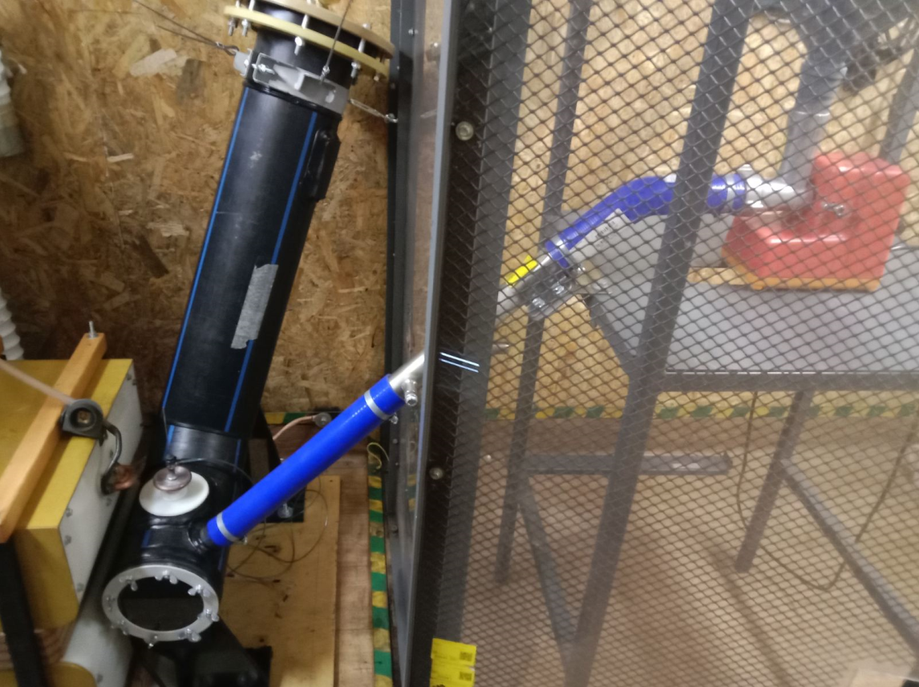
Figure 1 – EHSI UniThorr 2: working chamber and coal feeding device

The working chamber is a container made of polymer material, into which coal and water are fed, and where the electrohydraulic discharge occurs, leading to material grinding. Thanks to the circulation process created in the chamber, the ground particles are carried into the classifier and then into the clarification system, where the particles settle and are separated into fractions: coarse (20–200 µm) and fine (1–20 µm).
Brown coal of B1 grade was used for the research. The range of the initial fraction fed into the working chamber was 0–50 mm. Tap water was used as the working fluid. After separating the coal-water slurry (CWS) into fractions in the clarification system, CWF samples were prepared by mixing fractions of the required granulometric composition in different ratios. The uniform distribution of particles in the suspension volume was ensured by a ULAB US-2200D stirrer (1500 rpm for 10 minutes). The solid phase content was determined according to GOST P 52911-2020 [15]. Dispersion analysis of CWF samples was conducted using a FRITSCH ANALYSETTE 22 NanoTec laser particle size analyzer. Rheological studies were carried out using a RheoTest 2 rotational viscometer.
The sedimentation stability of CWF samples was determined visually: at specified intervals, the thickness of the layer separated from the suspension during settling was assessed. An increase in its height indicated the destabilization of the dispersed system, leading to the gradual compaction of the solid phase. Sedimentation stability S was calculated using the formula [16]:

$S=\frac{H_{0}- H_{c}}{H_{0}} ×100 \%$,

where H₀ – is the height of the initial sample layer;
H_{c} – is the height of the separated clarified layer.

Experimental Results
The critical characteristics of the slurry for obtaining CWF are the size of the coal particles and their quantity. Additionally, the grinding process is key and the most energy-intensive. Therefore, careful selection of equipment will reduce technological costs for fuel production. According to the main parameters of CWF (Table 2), the particle sizes of the dispersed phase should not exceed 250 µm. The influence of the dispersion composition on viscosity is crucial [17]. A properly selected granulometric composition of the solid phase helps reduce dynamic viscosity and increase suspension stability [14]. Accordingly, to meet the required technological parameters of CWF, such as dynamic viscosity and sedimentation stability, a finer fraction (particle size less than 150 µm) should be used.
As a result of grinding brown coal in the EHSI UniThorr 2, two types of CWS were obtained, differing in particle size: coarse and fine fractions.
Figure 2 shows the granulometric composition of the coarse fraction of CWS: 38% – particles sized 50–100 µm, 30% – 100–200 µm, 24% – 20–50 µm, 8% – less than 20 µm.
The fine fraction of CWS is mainly represented by particles sized 5–20 µm (48%) and 20–50 µm (12%). Particles sized 0.5–5 µm account for the remaining 40% of their total quantity, with the distribution of such particles being almost uniform and ranging from 6 to 10% (Figure 3).
Integral distribution of Q3(X), %

, %
Differential distribution of dQ3(X), %
Particle size, µm
Figure 2 - Integral and differential particle size distribution of the coarse particle fraction of the CWS
Integral distribution of Q3(X), %

, %
Differential distribution of dQ3(X), %
Particle size, µm

Figure 3 - Integral and differential particle size distribution of the highly dispersed CWS fraction

It was experimentally established (Figure 4) that reducing the mass fraction of coal from 46% to 40% allowed the dynamic viscosity of the CWS to decrease from 10 to 5.5 Pa·s at a shear rate of 13.5 s⁻¹. This indicates that preparing CWF solely from the fine fraction is impractical, as achieving the required rheological characteristics (no more than 1–2 Pa·s at a shear rate of 13.5 s⁻¹) necessitates reducing the mass fraction of the solid phase to below 40%.
Moreover, it is impractical to use only the coarse fraction separately from the fine fraction for preparing CWF, due to the following factors:
- Low sedimentation stability (separation occurs within a few minutes).
- High dynamic viscosity (from 10 Pa·s at a shear rate of 13.5 s⁻¹).
- Insignificant content of the coal solid phase.

Figure 4 - Rheological curves of dynamic viscosity dependence on shear rate at changing the mass fraction of highly dispersed fraction of CWS

Incorporating a coarse-dispersed fraction of CWS into a highly dispersed one in various ratios allows for a reduction in dynamic viscosity from 10 to 1.6 Pa·s at a shear rate of 13.5 s^{–1}, while simultaneously increasing the content of the coarse-dispersed fraction in the solid phase to 70–80% (Figure 5).

Figure 5 – Rheological curves of dynamic viscosity dependence on shear rate at changing the mass fraction of coarse-dispersed fraction of CWS

Experimental data revealed that the highest stability is exhibited by CWF samples without any addition or with up to 30% of the coarse-dispersed fraction (of the total solid phase mass). However, such samples are characterized by high dynamic viscosity (Figure 5). Introducing more than 30% of the coarse-dispersed fraction deteriorates stability indicators, and more than 80% leads to the formation of a dense, hard-to-mix sediment within the first 12 hours.
Figure 6 presents the results of the dependence of sedimentation stability of СWF samples on sedimentation time at various contents of the coarse-dispersed fraction.
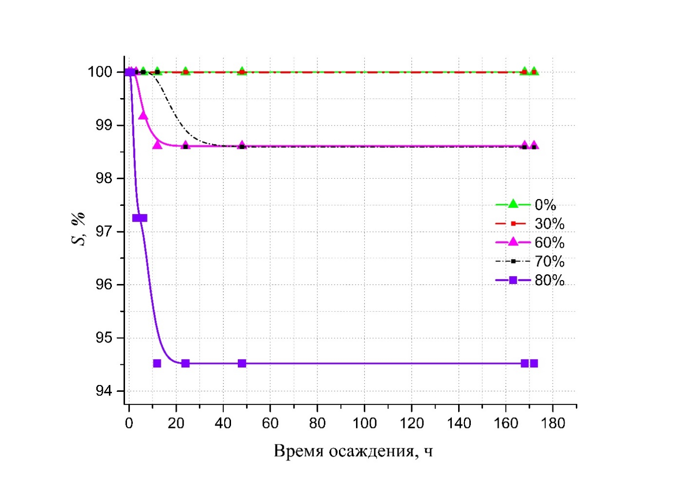
Figure 6 – Dependence of sedimentation stability of CWF samples on sedimentation time at various contents of the coarse-dispersed fraction of CWS

It has been established that the dynamic viscosity of the studied samples of CWF decreases with an increase in the number of particles sized 50–100 µm, as well as with the expansion of the range of the smallest and largest particles in the dispersed system. This is due to the more compact structure of the system, as the small particles fill the voids between the larger ones and displace the liquid, leading to improved flowability of the CWF and an increase in the solid phase content. Thus, by adjusting the granulometric composition of the CWF, it was possible to reduce the dynamic viscosity of the samples by six times.
Experimentally, a formulation for the preparation of CWF was developed, meeting the requirements for the mass fraction of the solid phase (coal content 46 %), dispersion composition (70 % coarse dispersion (less than 200 µm) and 30 % high dispersion (less than 50 µm) fractions), rheological properties (dynamic viscosity not more than 2 Pa·s), and sedimentation stability (more than five days). This information formed the basis for the development of the principal technological scheme for the production of CWF.
Technology of CWF Production using EHSI
Main stages of CWF production (Figure 7):
– Preliminary processing of the raw material (brown coal). At this stage, it is necessary to separate the raw material from coarse and metallic inclusions. Additionally, the raw material may be enriched, dried, etc.
– One- or two-stage grinding of coal in an aqueous medium, resulting in the formation of CWF. The first stage involves coarse grinding in a mill, and the second stage involves fine grinding. This method optimizes the granulometric composition of CWS and positively affects the dynamic viscosity of CWF.
– Final stage: obtaining CWF by introducing stabilizing or plasticizing additives.

Preparation of Raw Materials
Obtaining CWF
Grinding

Figure 7 – Main Stages of CWF Production.

The principal technological scheme for CWF production using EHSI is presented in Figure 8.

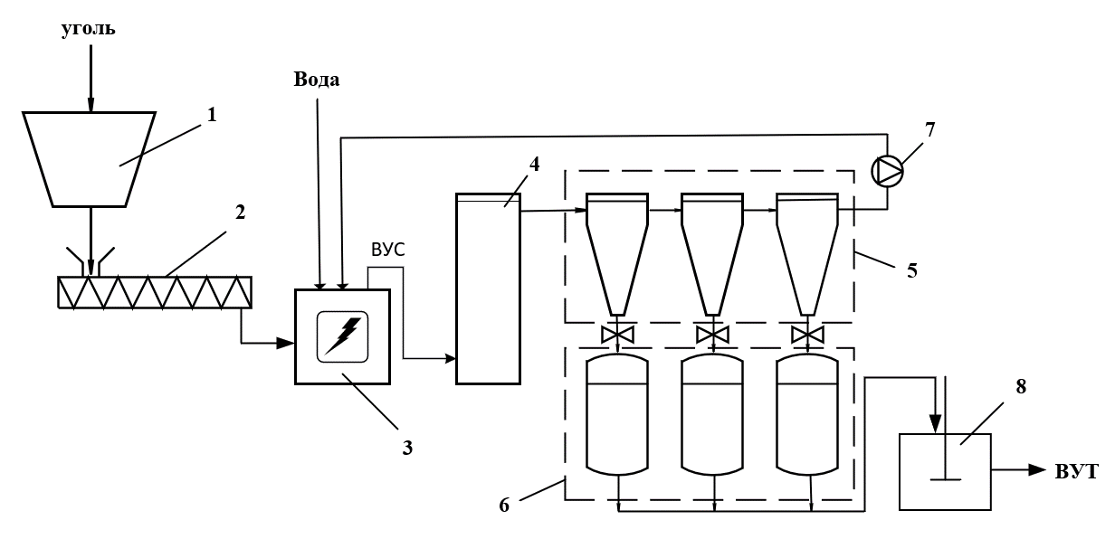
Figure 8 – Basic technological scheme for CWF production: 1 – Raw material hopper; 2 – Screw feeder; 3 – EHSI discharge chamber; 4 – Classifier; 5 – Clarification system; 6 – CWS storage tanks; 7 – Centrifugal pump; 8 – Reactor for CWF production
From the raw material hopper 1, after passing through the magnetic separator, the coal is fed together with water into the EHSI discharge chamber 3 using the screw feeder 2, where it is ground, resulting in CWS. The CWS then moves through the classifier 4 and the clarification system 5, where the suspension is separated into coarse and fine fractions. The fractions are then discharged into the storage tanks 6, from where, after checking the dispersion composition of the CWS, they are directed in the required proportion to the reactor for CWF production 8. Water is added here if necessary. The circulation of liquid in the EHSI is carried out by the centrifugal pump 7.

Conclusion
To implement the EcoSpace program within the framework of obtaining energy and biohumus in the equatorial linear city for the needs of the General Planetary Vehicle and the ISN “Orbit” (in the future – up to a billion tons annually), it is proposed to use such natural raw materials as coal, of which planetary reserves are sufficient.
The study demonstrates the possibility of using EHSI to obtain CWF, highlighting the main advantages of the electrohydraulic effect. The presented data have been confirmed by scientific research conducted in 2022–2024 on the experimental modernized UniThorr 2 installation, designed by employees of Unitsky String Technologies Inc.
A technological scheme for CWF production using the electrohydraulic effect was developed experimentally, revealing the relationships between the technological parameters of CWF and determining the optimal fuel composition.
Further research will focus on improving the CWF formulation and determining the impact of the natural characteristics of raw materials on its technological properties. Experiments with oil shale as an alternative to brown coal are planned.

References
1. Unitsky, А.E. String Transport Systems: On Earth and in Space: scient. edition // A.E. Unitsky. – Gomel: Infotribo, 1995. – 337 p.: il.
2. Unitsky, А.E. String Transport Systems: On Earth and in Space: scient. edition // A.E. Unitsky. – Silakrogs: PNB Print, 2019. – 576 p.
3. Unitsky, А.E. Sozdanie matematicheskoj modeli obshcheplanetarnogo transportnogo sredstva: razgon mahovikov, prohozhdenie atmosfery, vyhod na orbitu [Creation of a mathematical model of the General Planetary Vehicle: flywheel acceleration, atmospheric passage, orbital entry] / A.E. Unitsky, R.A. Sharshov, A.A. Abakumov // Non-Rocket Near Space Industrialization: Problems, Ideas, Projects: Collection of Articles of the II International Scientific and Technical Conference, Maryina Gorka, Jun. 21, 2019 / Astroengineering Technologies LLC; ed. A. Unitsky. – Minsk: Paradoks, 2019. – P. 77–83.
4. Non-Rocket Near Space Industrialization: Problems, Ideas, Projects: Collection of Articles of the III International Scientific and Technical Conference, Maryina Gorka, Sept. 12, 2020 / Astroengineering Technologies LLC; ed. A. Unitsky. – Minsk: StroyMediaProyect, 2021. – 516 p.
5. Unitsky, А.E. Inzhener: avtobiografiya [The Engineer: Autobiography] / A.E. Unitsky. – Minsk: Belprint, 2021. – 400 p.
6. Unitsky, A.E. System Foundations of Non-Rocket Near Space Industrialization: Problems, Ideas, Projects / ed. A. Unitsky. – Minsk: Gradient, 2021. – 568 p.
7. Yutkin, L.A. Elektrogidravlicheskij effekt i ego primenenie v promyshlennosti [Electrohydraulic effect and its application in industry] [ / L.А. Yutkin. – L.: Mashinostroenie, 1986. – 253 p.
8. Varianty primeneniya elektrogidroudarnoj ustanovki v usloviyah prozhivaniya lyudej v kosmose [Options for the application of electrohydraulic shock installation in human habitation in space]/ А.E. Unitsky, N.S. Pershai, S.А. Arnaut // Non-Rocket Near Space Industrialization: Problems, Ideas, Projects: Collection of Articles of the VI International Scientific and Technical Conference, Maryina Gorka, Oct. 7–8, 2023 / Astroengineering Technologies LLC, Unitsky String Technologies Inc.; ed. A.E. Unitsky. – Minsk: StroyMediaProyect, 2024. – P. 322–335.
9. Ispol'zovanie elektrogidroudara v tekhnologii prigotovleniya vodougol'nogo topliva [Use of electrohydroshock in the technology of preparation of coal-water fuel] / А.E. Unitsky, N.S. Pershai, S.А. Arnaut // Effektivnost' inzhenernyh sistem i energosberezhenie: sb. st. mezhdunar. nauch.-prakt. konf [Efficiency of Engineering Systems and Energy Saving: Collection of Articles of the International Scientific and Practical Conference], Brest, Oct. 19–20 2023 / M-vo obrazovaniya Resp. Belarus', Brest. gos. tekhn. un-t; ed. V.G. Novoseltseva. – Brest: Izd-vo BrGTU, 2023. – P. 128–136.
10. Statistical Review of World Energy. 2020. 69th ed. [Electronic resource]. – Mode of access: https://www.bp.com/content/dam/bp/business-sites/en/global/corporate/pdfs/energy-economics/statistical-review/bp-stats-review-2020-full-report.pdf. – Date of access: 12.06.2024.
11. Prirodnye resursy mirovoj ekonomiki [Natural resources of the world economy] [Electronic resource]. – Mode of access: https://mirec.mgimo.ru/2014/2014-02/prirodnye-resursy-mirovoj-ekonomiki?utm_source=google.com&utm_medium=organic&utm_campaign=google.com&utm_referrer=google.com. – Date of access: 14.06.2024.
12. Unitsky, А.E. Engineering. The world as an engineering project / А.E. Unitsky // Non-Rocket Near Space Industrialization: Problems, Ideas, Projects: Collection of Articles of the VI International Scientific and Technical Conference, Maryina Gorka, Oct. 7–8, 2023 / Astroengineering Technologies LLC, Unitsky String Technologies Inc.; ed. A.E. Unitsky. – Minsk: StroyMediaProyect, 2024. – P. 22–135.
13. China’s Coal Use Increased to a Record High in 2022, IEA Says [Electronic resource]. – Mode of access: https://www.rfa.org/english/news/environment/coal-07282023072108.html. – Date of access: 17.06.2024.
14. Baranova, M.P. Kompleksnaya tekhnologiya polucheniya i transporta vodougol'nyh toplivnyh suspenzij iz uglej raznoj stepeni metamorfizma [Complex technology of production and transportation of water-coal fuel slurries from coals of different degrees of metamorphism]/ M.P. Baranova // ZHurnal Sibirskogo federal'nogo universiteta. Seriya: Tekhnika i tekhnologii. – 2011. – Vol. 4, № 6. – P. 613–619.
15. Toplivo tvyordoe mineral'noe. Opredelenie obshchej vlagi: GOST R 52911-2020 [Solid mineral fuel. Determination of total moisture: GOST R 52911-2020] [Electronic resource]. – Mode of access: https://files.stroyinf.ru/Data/744/74490.pdf. – Date of access: 18.06.2024.
16. Sverchkov, I.P. Snizhenie vybrosov zagryaznyayushchih veshchestv pri termicheskoj utilizacii othodov ugleobogashcheniya: dis. ... kand. tekhn. nauk [Reduction of pollutant emissions at thermal utilization of coal preparation wastes: Cand. … Cand. Sci. Tech.]: 25.00.36 / I.P. Sverchkov. – SPb., 2019. – 197 p.
17. Dolinskiy, А.А. Vodougol'noe toplivo: perspektivy ispol'zovaniya v teploenergetike i zhilishchno-kommunal'nom sektore [Water-coal fuel: prospects for use in heat and power engineering and housing and communal sector] / А.А. Dolinskiy, А.А. Halatov // Promyshlennaya teplotekhnika. – 2007. – Vol. 29, № 5. – P. 70–79.

